Lecture 2, August 26, 2010 (Key Points)

Over the past few decades, Hydrology has been maturing as a new geophysical science that deals with the cycling of water in the natural environment that relate specifically with (Eagleson, 1991):)

The continental water processes, namely the physical and chemical processes along the various pathways of continental water (solid, liquid and vapor) at all scales, including those biological processes that influence this water cycle directly (Fig.1.1, Brutsaert, 2005); and with

The global water balance, namely the spatial and temporal features of the water transfers (solid, liquid and vapor) as fluxes (m³/s) between all compartments of the global system, i.e. atmosphere, oceans and continents, in addition to stored water quantities (m³) and residence times (sec.) in these compartments (Table 1.1, Brutsaert, 2005).

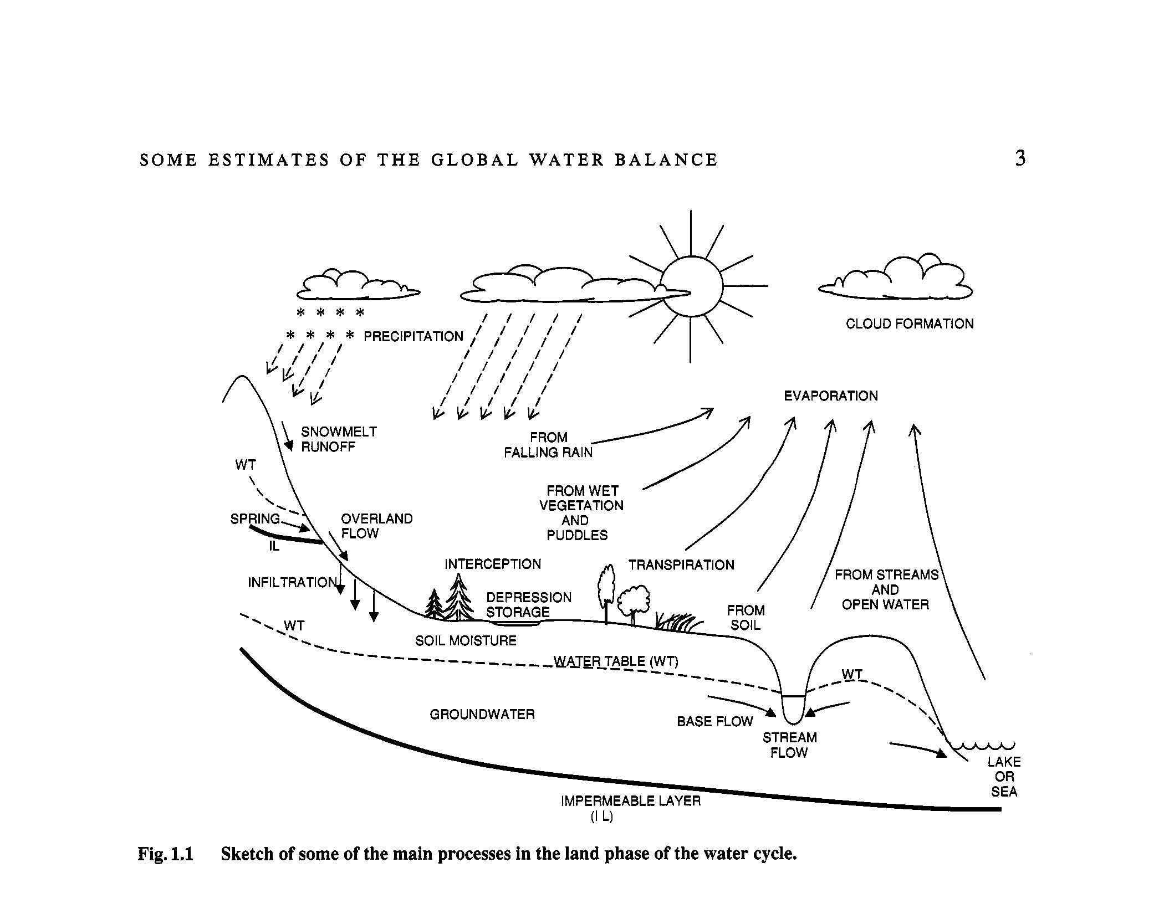

Hydrology dealing with the continental water processes is a discipline distinct from meteorology, climatology, oceanology, glaciology, and others that also deal with the water cycle in their own specific domains, namely the atmosphere, the oceans, the ice masses, etc., of the Earth. At the same time, however, hydrology integrates and links these other geosciences, in that through the global water balance it is also concerned with the exchanges of water between all these separate compartments.

Long-term water balance
The long-term water balance is written as,

(2.1)
where “bar” denotes” long-term means (annual or longer). Here we assume that, storage change,, and that subsurface fluxes are negligible. Note the following points:
  - Presence of cycles and periodicities can influence the approximation, . For example, at time scales shorter than a year, diurnal and seasonal cycles are present. Likewise, at longer timescales than annual, quasi-periodic behavior, e.g, due to El Niño/Southern Oscillation (ENSO), can influence the terms of the water balance.
  - A careful understanding of the time scales over which long-term water balance approximation applies is needed using modern large-scale hydroclimatic data sets. It is an important topic of hydro-climate research.
  - Drainage basins cover a very wide range of spatial scales from ~1 km² to ~10⁶ km². The Amazon basin in South America has a drainage area of 7.0 million km², the Congo basin in Africa has a drainage area of 3.7 million km², and the Mississippi, 3.3 million km².
  - Heterogeneities of the soil properties governing soil moisture, the spatial variability of vegetation associated with precipitation, interception, evaporation, and infiltration processes, and anthropogenic influences on landscapes, make all the terms in the water balance depend on spatial scales.
  - Moreover, the water balance eq. (2.1) needs to be understood on the multiple spatial scales of a drainage network rather than for arbitrary geographic regions. We will see in this course why a basin perspective is necessary from a physical point of view (Section 3) !

Global Estimates of water Balance

Table 1.1 (Brutsaert, 2005) gives five estimates of world water balance (m y^{-l}) from five different references. Table 1.3 gives estimates of different forms of global water storages as depth in m over the entire surface of the globe. Observe that rivers have the smallest value among all other components.

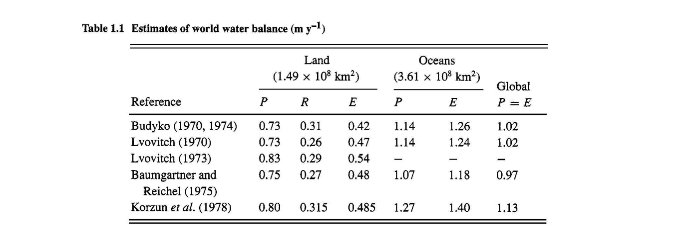Scale Issues in Nature
For a fascinating example of scales in our universe is given in “Powers of Ten”. I will show a power point presentation in the class. You may also explore the video through the link below.
http://micro.agnet.fsu.edu/primer/java/scienceopticsu/powersof10/

What is the scale issue in Hydrology?
Spatial patterns tend to change as spatial scale changes, as seen in the “Powers of ten” video. Also the patterns exhibit variability. This suggests that the physical processes that dominate at one spatial scale, and the corresponding time scale, are different from the processes that dominate at another space-time scale. Several spatial scales are illustrated with the corresponding characteristic temporal scales in Figure 1.2 (Brutsaert, 2005) for some general types of water transport processes as they have been considered in hydrologic studies.

The scale issue refers to understanding how processes, patterns and statistical variability are coupled across a range of space and time scales. Recognition of the foundational importance of scale in hydrology has grown since the 1980s. It is having a profound impact on our understanding of hydrology as a geophysical science that has major implications for developing new tools in scientific and engineering hydrology. Scale issues arise in many natural sciences.

Spatial Scale and Parameterization (Brutsaert, I.4.3, 2005)
All natural flow phenomena are governed by the principles of conservation of mass, momentum and energy, which are expressed by a number of equations to provide a mathematical description. However, because there are normally more dependent variables than available conservation equations, in order to close the system, additional relationships must be introduced. These closure relationships, also called parameterizations, relate some of the variables with each other to describe certain specific physical mechanisms; the mathematical form of these relationships, and the values of the material constants or parameters are usually based on experimentation.
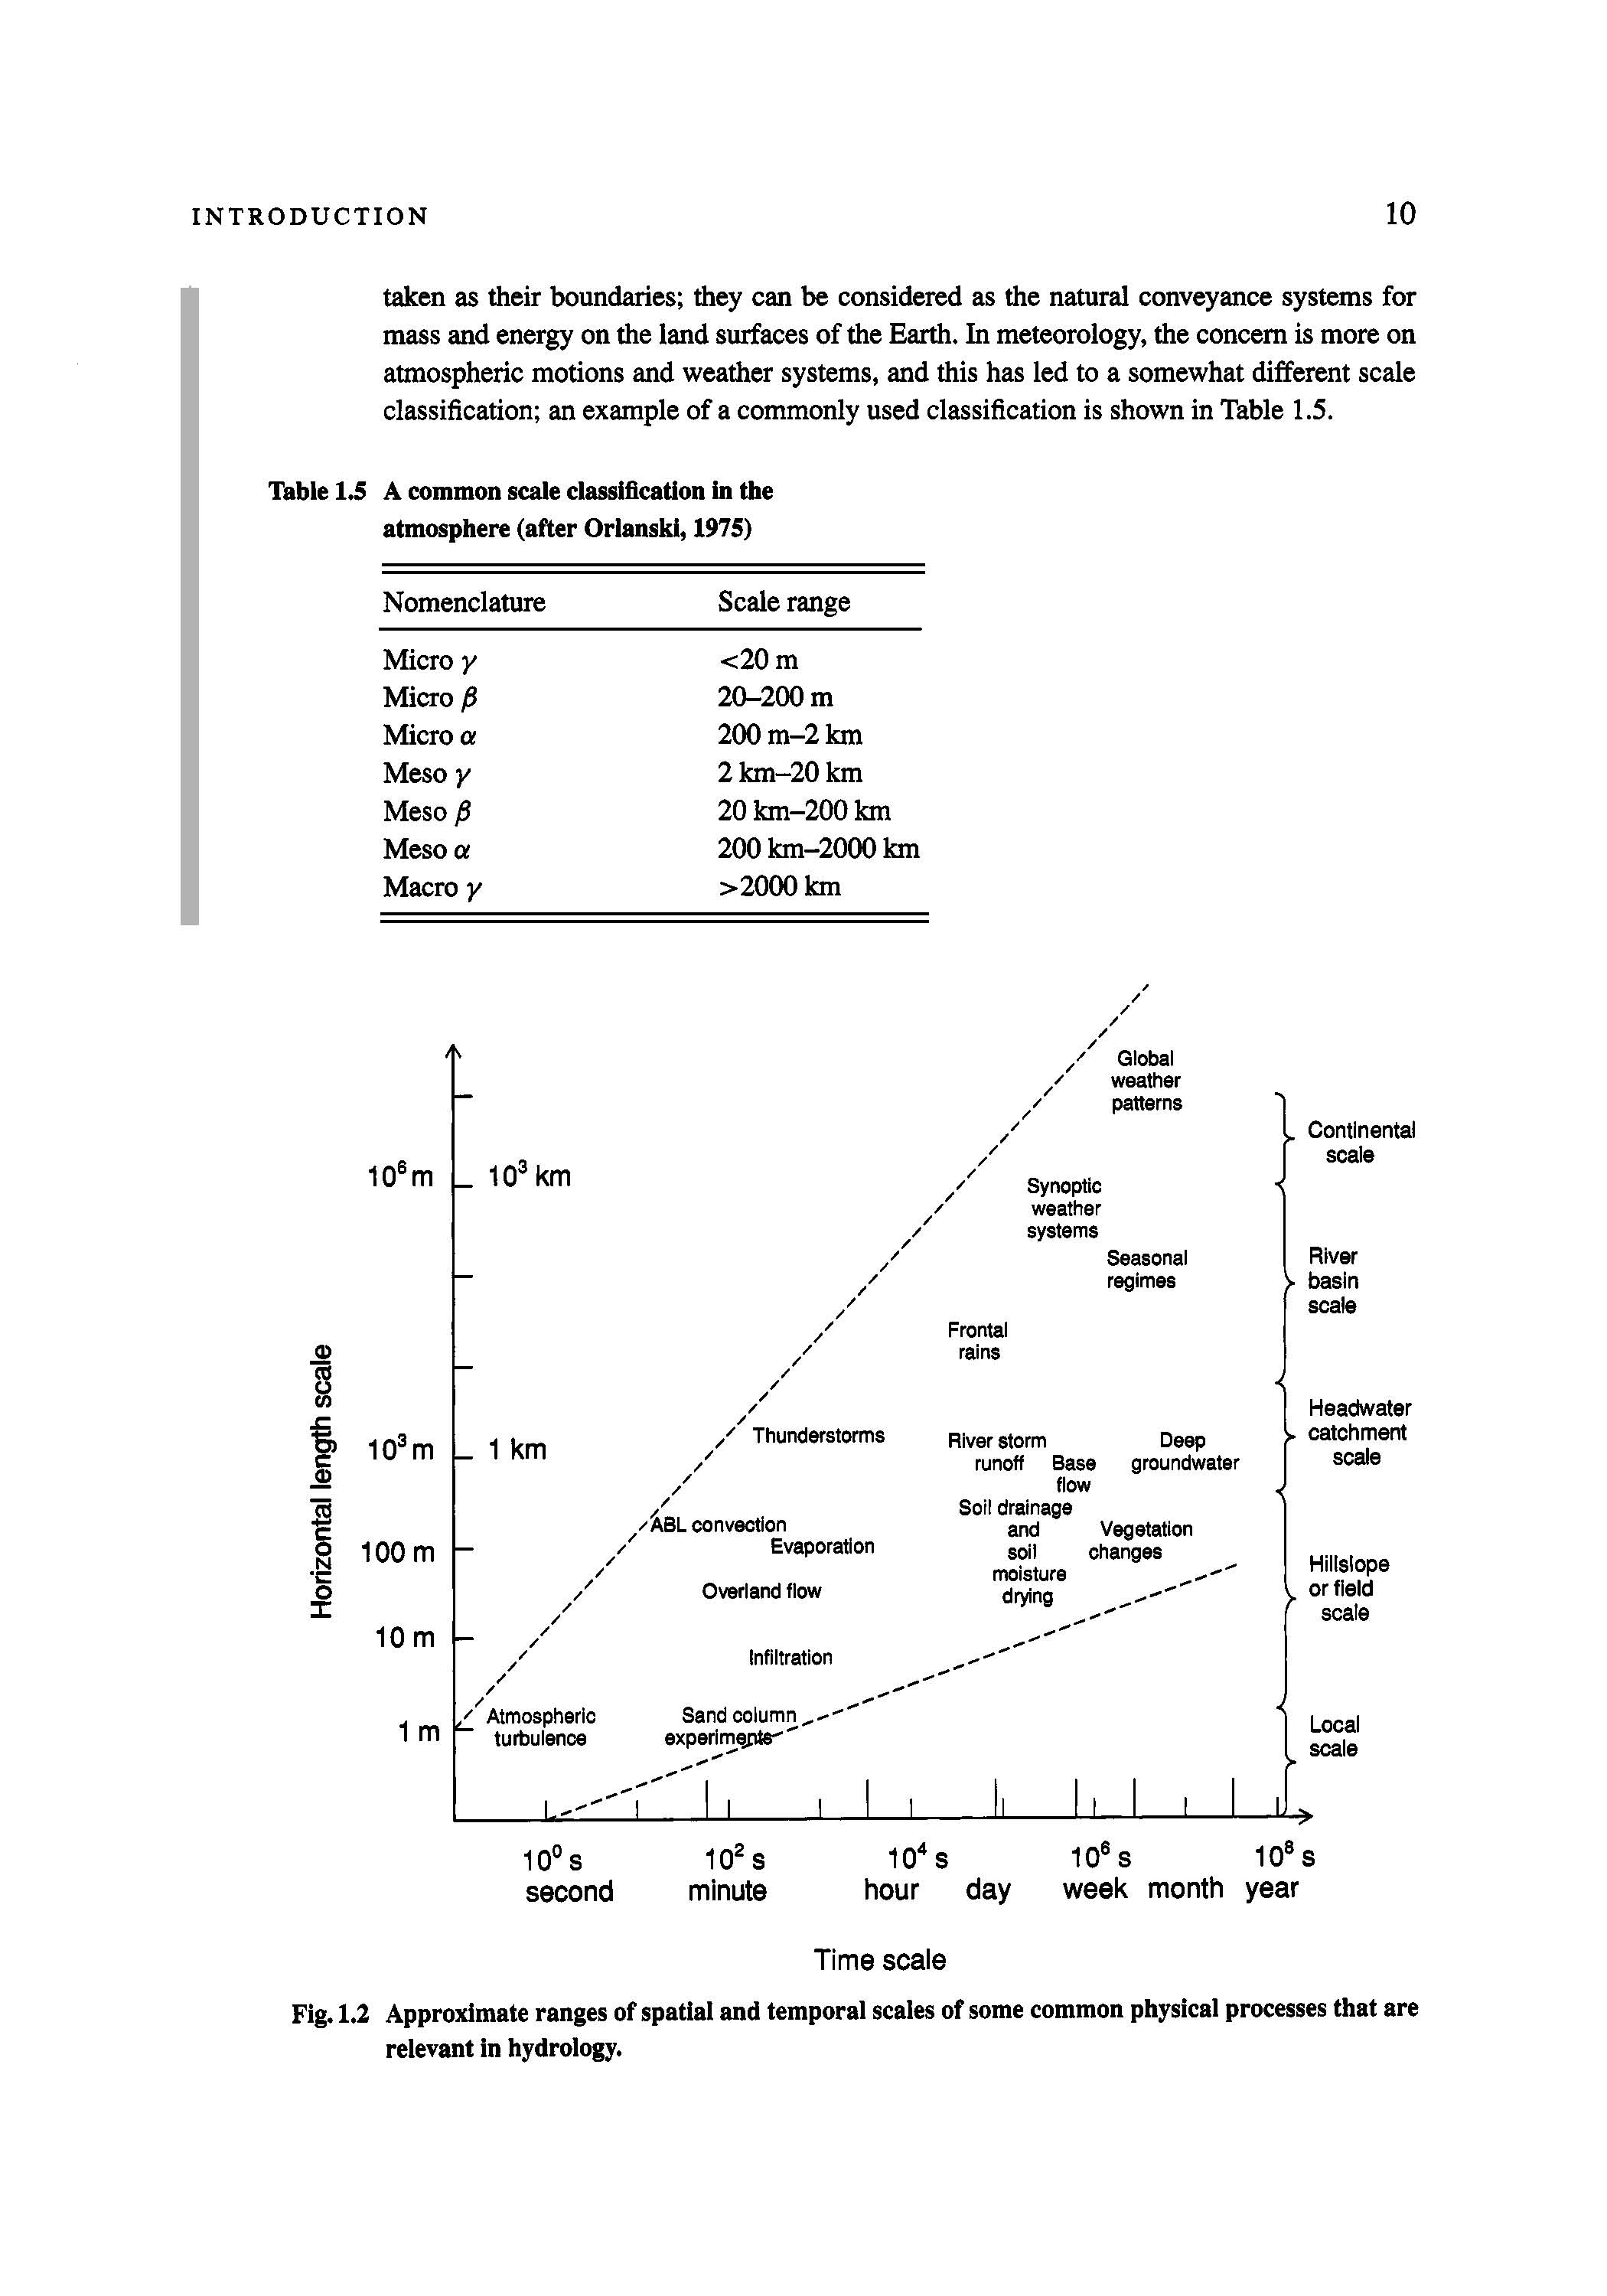
Any physical phenomenon must be considered at a given scale; this scale is the available (depending on the data) or chosen (depending on the objectives of the study) resolution. While the fundamental conservation equations remain unaffected by the scale at which the phenomenon is being considered, most closure relationships in them are quite sensitive to scale. Indeed, a parameterization can be considered as a mathematical means of describing the subresolution (or microscale) processes of the phenomenon, in terms of resolvable scale (or macroscale) variables; these macroscale variables are the ones, which can be treated explicitly in the analysis or for which measured records are obtainable. Thus, the details of the microscale mechanisms are not considered explicitly, but their statistical effect is formulated mathematically by a parameterization in terms of macroscale variables.
A sound criterion to distinguish, in principle at least, one approach from another, may be the spatial scale at which the internal mechanisms are parameterized. For example, Newton’s equation for viscous shear stress is a parameterization in terms of variables typically at the millimeter to centimeter scale; however, it reflects momentum exchanges at molecular scales, which are orders of magnitude smaller. The hydraulic conductivity is a parameter at the so-called Darcy scale, namely a scale somewhere intermediate between the Newtonian viscosity (Navier-Stokes equations) scale for water and air inside the soil pores, on the one hand, and the field scales for infiltration and drainage, on the other.
On the land surfaces of the Earth, the catchment or river basin size appear as scales of central importance. The terms basin, catchment, watershed and drainage area are roughly synonymous and are often used interchangeably. A basin can be defined as all of the upstream area, which contributes to the open channel flow at a given point along a river. However, a basin or catchment can also defined by any point along the river, where the river flow is being measured. Basins are delineated naturally by the land surface topography, and topographic ridges are usually taken as their boundaries. A channel network embedded in a land-surface has multiple spatial scales that are explained in Section 5. Drainage basins can be considered as the natural conveyance systems for mass and energy on the land surfaces of the Earth. We will introduce new developments pertaining to mass and momentum conservation equations that are dictated by the partitioning of a land surface topography by a channel network (Section 7).

Spatial variability and effective parameters
As mentioned above, a parameterization can be defined as a functional relationship between the variables describing the phenomenon in question. This relationship invariably contains one or more constant terms, reflecting material and fluid properties and vegetational, geomorphic, geologic and other physiographic features; these are called parameters and they are normally determined by experiment. Most hydrologic parameters tend to be highly variable in space. It stands to reason, therefore, that the experimental determination of any such space-dependent parameter must be carried out at the scale at, which it is to be applied to describe the flow. The complexity of dynamic parameters in the conservation equations in explained in Section 8.

A second important issue is that any given parameterization is usually valid only over a certain finite range of spatial scales, and that the computational scale, that is the integration domain or the discretization of the equations, must lie within that range. Because the necessary data may be available only at a coarser resolution, in practical application a parameterization may have to be applied at scales, for which it was not intended originally and which are larger than permissible. This means in such a case that the spatial variability of the parameters at the finer scales, which is normally present in the natural environment, cannot be accounted for with the available data. This difficulty is often resolved by assuming that the parameterization is still valid at the larger scale, and that it can be implemented with averaged or effective values of the parameters. This approach is not satisfactory, and it has led to the practice of “model calibration” in engineering hydrology. An important objective of this course is to explain and illustrate the concept of “model testability”, which stands in direct contrast to model calibration (Section 7).

References:
Brutsaert, W. 2005: Hydrology: An introduction, Cambridge.

Eagleson, P. S. (chair) 1991: Opportunities in the Hydrologic Sciences, National Academy Press, Washington D.C.

